BRAINSTORM & IDEA PRIORITIZATION TEMPLATE

|  |  |
| --- | --- |
| Date | 27 September 2022 |
| Team ID | PNT2022TMID47721 |
| Project Name | Analytics For Hospitals’ Health-Care Data |
| Maximum Marks | 4 Marks |

Step-1: Team Gathering, Collaboration and Select the Problem Statement

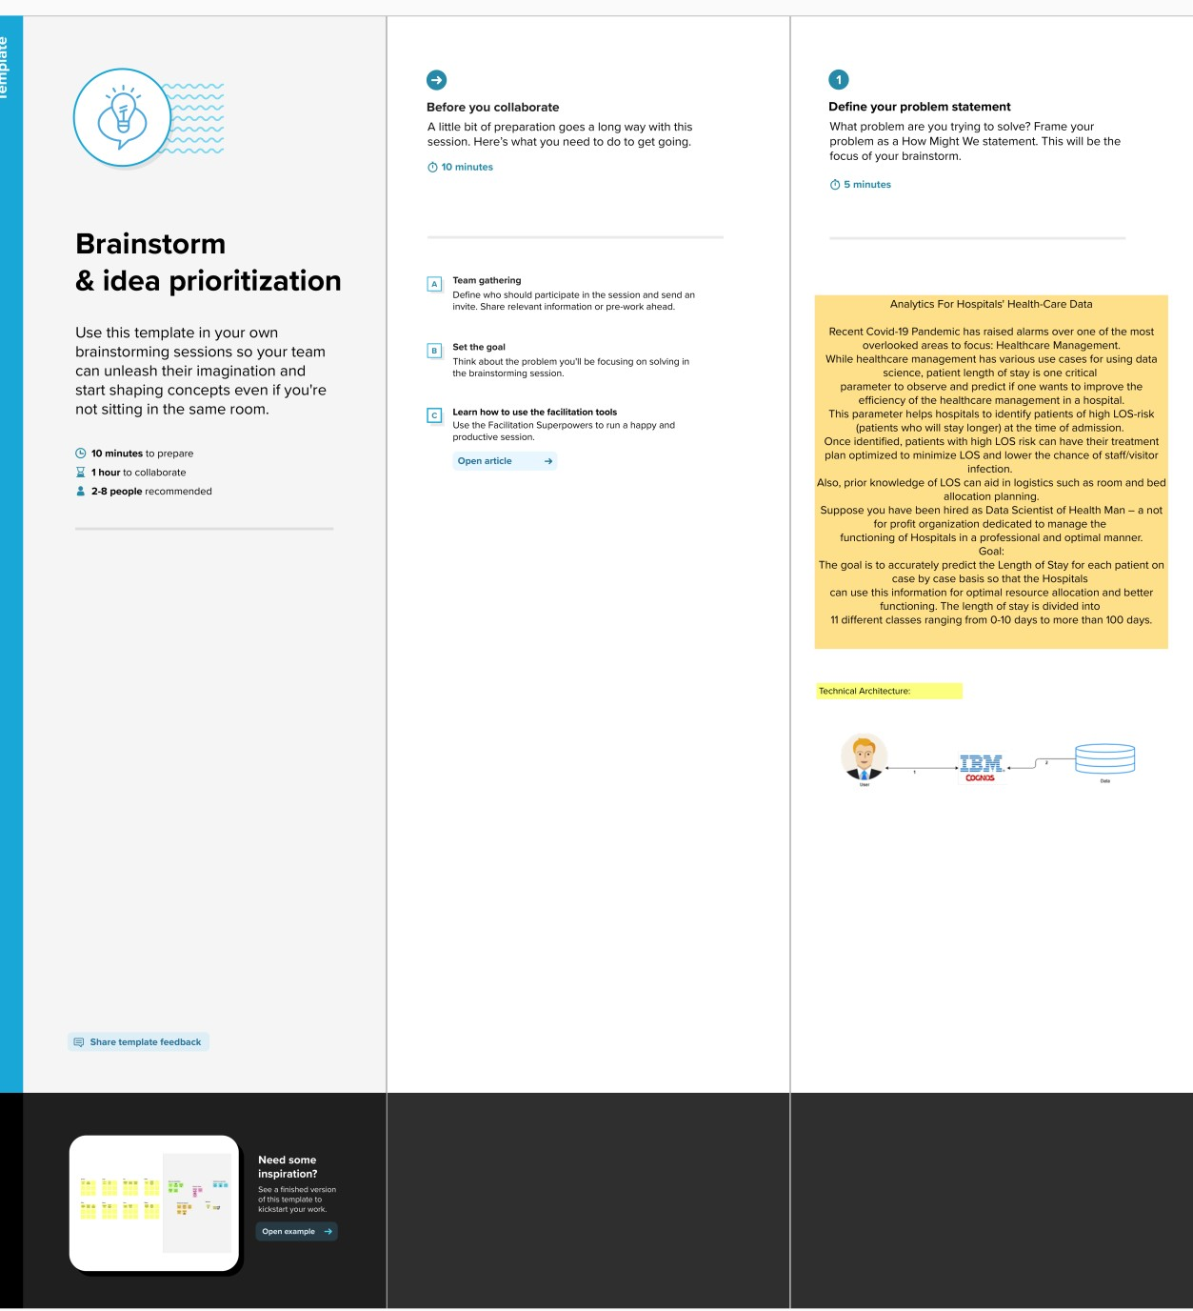

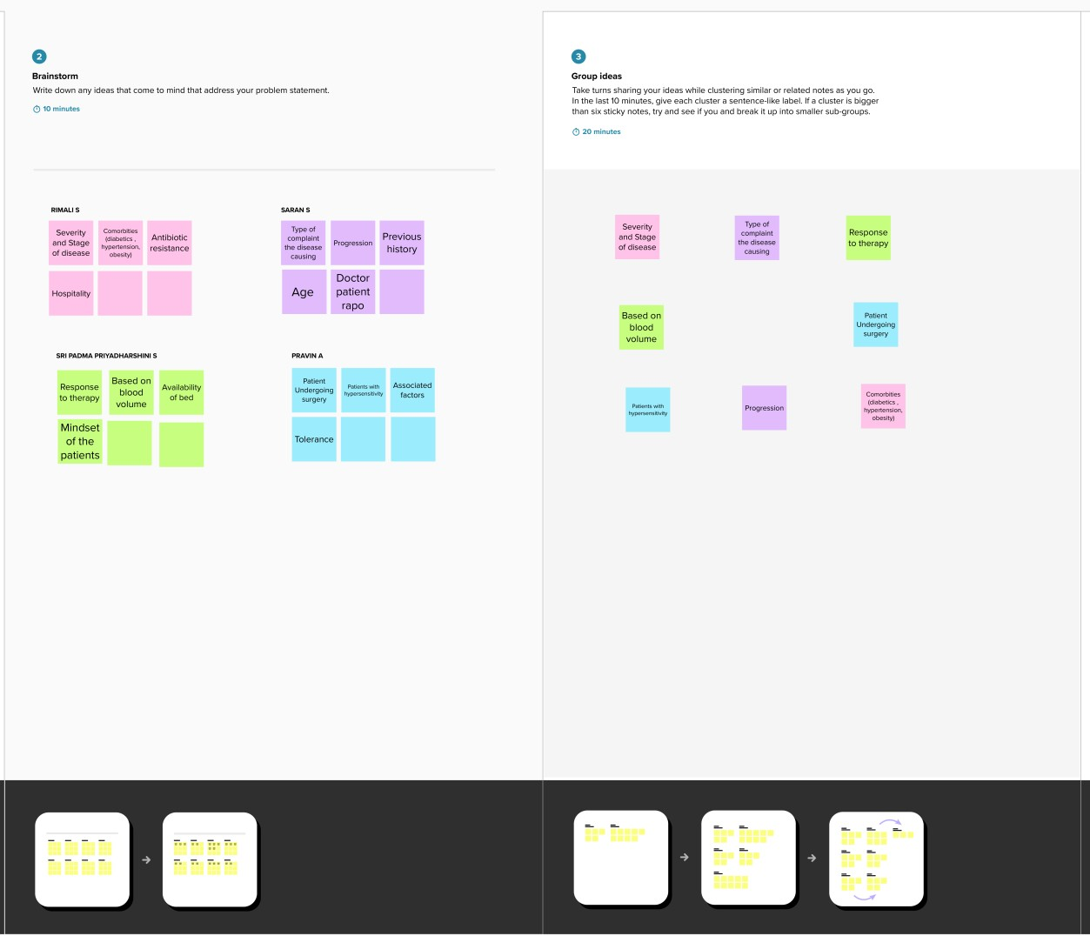

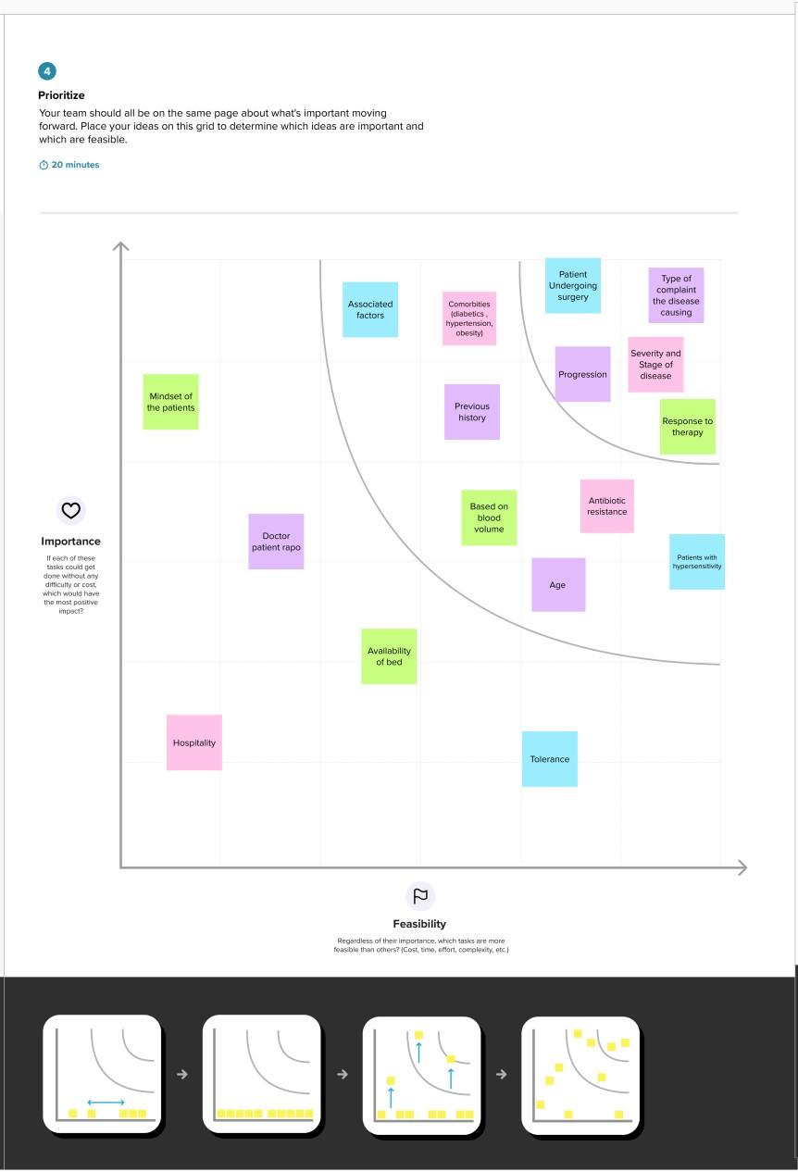

Sabari Raja(Team Leader)

Vigneshwaran(Team Member)

Siraj Anwardeen(Team Member)

Shakkif Ibrahim(Team Member)